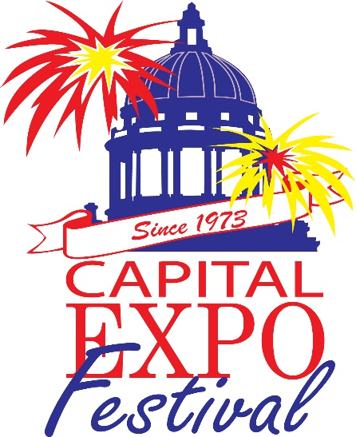

Sponsorship opportunities

Most sponsors are at the $2,000, level and receive all benefit listed:
- Standard Vendor Space
- Two (2) Logo Banners (state area and prime/heavy traffic area)
- Logo Listing in all printed advertising, State Journal & Brochures
- Mention in all radio & television advertising
- Logo Listing on Capital Expo Website
Med-level $1,000 sponsors received:
- Vendor Space
- One (1) banner
- Listing in all printed advertising, State Journal & brochures
- Name listing on website
Friend of Expo $500.00 sponsors receive:
- Listing on Thank You Ad
Some sponsors agree to more than the $2,000.00 level to receive a larger benefit as being a co-sponsor or sponsor of an event.
Please call for more information regarding information.
Contact: Miranda Marston 859-489-0130 mmarston@stockton.com
Thank you for your consideration!

